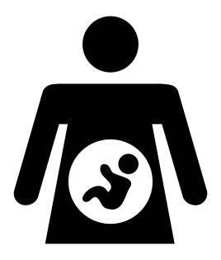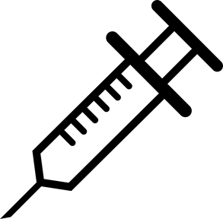
Long Bennington Medical Centre
Patient Information Sheet – Pregnancy and the MMR Vaccine

IF YOU ARE THINKING OF HAVING A BABY

If you are considering becoming pregnant it’s a good idea to check that you are fully protected against measles, mumps and rubella.

Rubella infection in pregnancy can lead to serious birth defects and miscarriage.

If you’re not sure you’ve had two doses of the MMR vaccine, ask us and our Practice Nurses can check for you.

If you haven’t had both doses or there is no record available, you can have the vaccine here at the Practice.

You should avoid becoming pregnant for one month after having the MMR vaccination.

IF YOU ARE ALREADY PREGNANT

The MMR vaccine cannot be given while you are pregnant, but it can be given when you are breastfeeding.

If you are currently pregnant and you are not sure whether you have had two doses of MMR, ask and our Practice Nurses will check for you.

If you haven’t had two doses of the MMR vaccine or there is no record available, you can ask for the vaccine when you attend for your six week postnatal check-up. Once vaccinated, you will be protected from rubella in any future pregnancies.

If you are pregnant and develop a rash or come into contact with anyone who has a rash, you should contact your GP or midwife as soon as possible, even if you have had two doses of the MMR vaccine.

